**Displaying Time Series Data from Edge Device in a Mashup**

1. Create new Thing

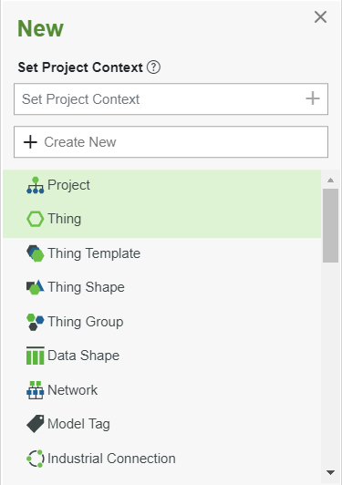

1. Fill out General Information
   1. Name = Initials_Temperature_Sensor
   2. Project = ESRAP_Meetings_Exercises
   3. Base Thing Template = RemoteThing

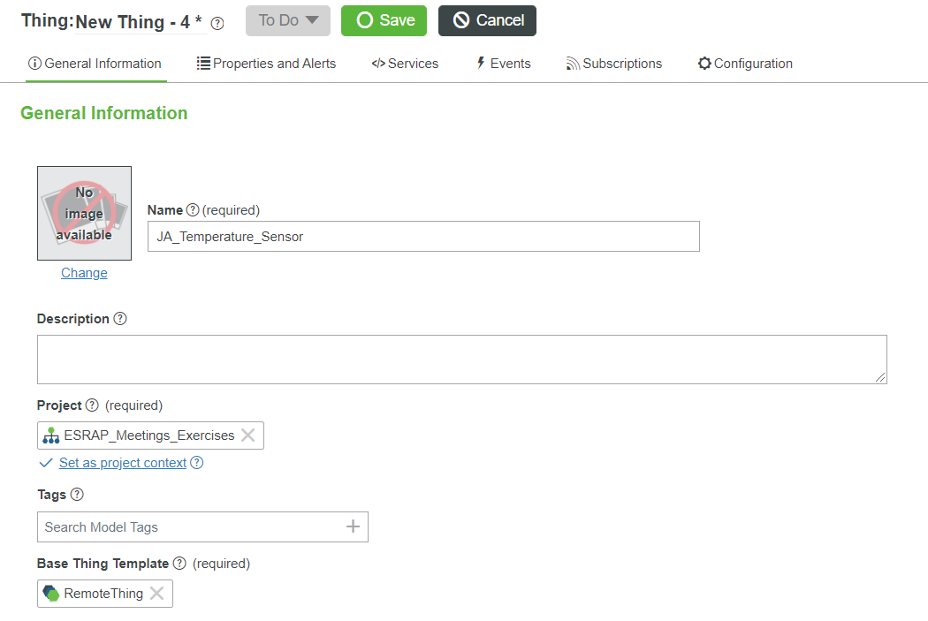

1. Go to Properties and Alerts -> Add Property
   1. Fill in the information as in the following image:

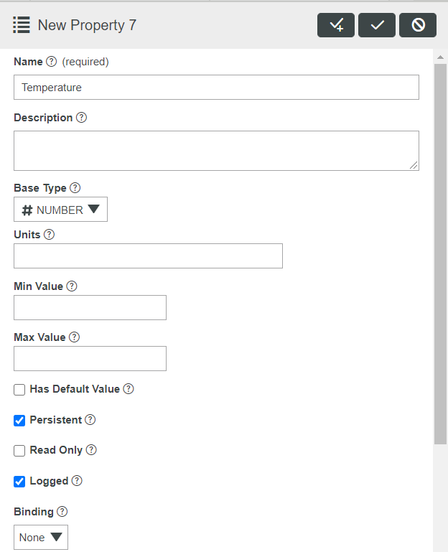

* 1. Save

1. Create new Value Stream

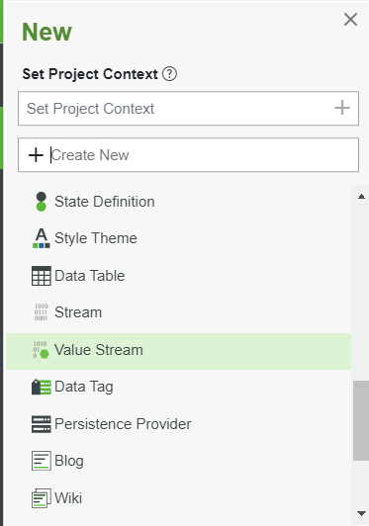

* 1. Select ValueStream -> OK

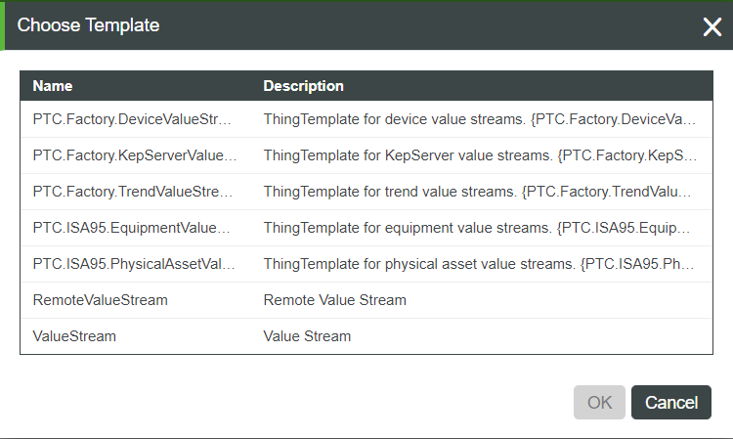

1. Fill in Information:
   1. Name = Initials_Temperature_Sensor_ValueStream
   2. Project = ESRAP_Meetings_Exercises

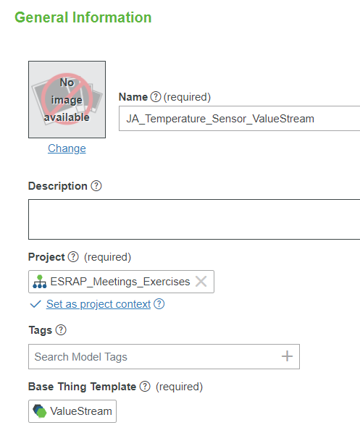

* 1. Save

1. Navigate to Initials_Temperature_Sensor Thing
   1. Add a Value Stream on General Information tab

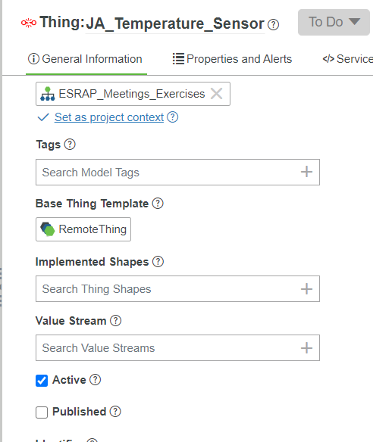

* 1. Select the previous created Value Stream

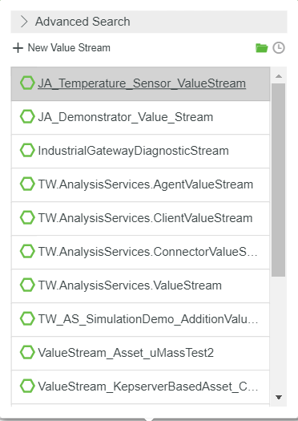

* 1. Save

1. Create a Mashup

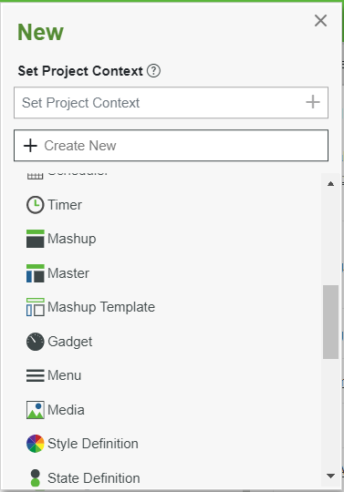

* 1. Select Responsive

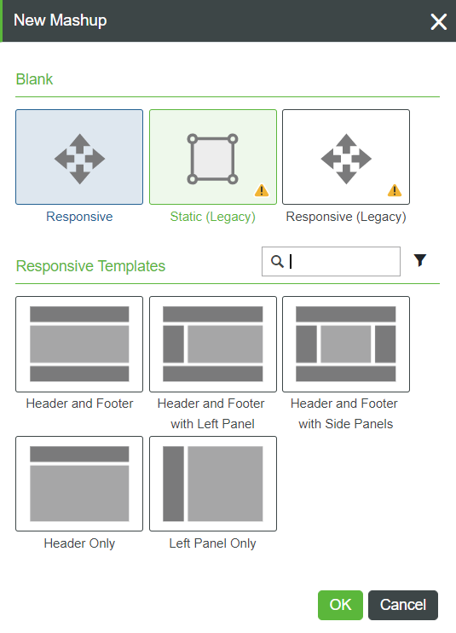

1. Fill in General Information
   1. Name = Initials_Temperature_Sensor_Mashup
   2. Project = ESRAP_Meetings_Exercises

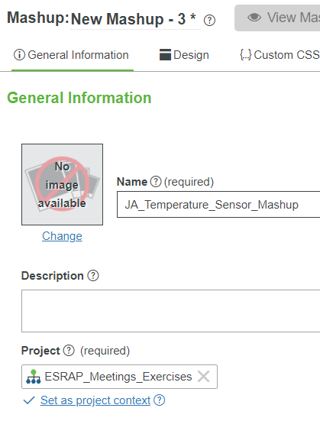

1. Switch to the Design tab
   1. Select Widgets

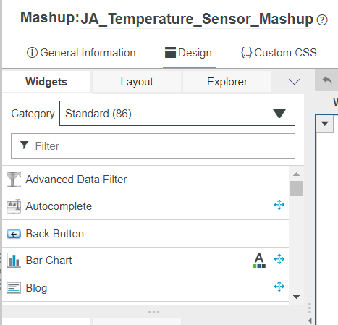

* 1. Use the Filter to select Time Series Chart
  2. Drag and drop the Time Series Chart to the container

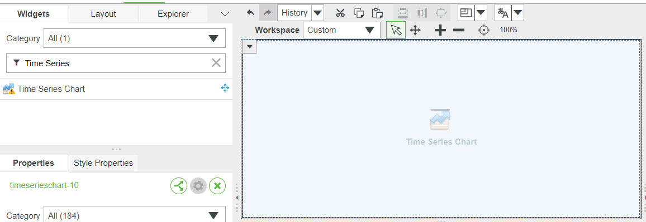

1. On the right side of the screen navigate to Data and click on add

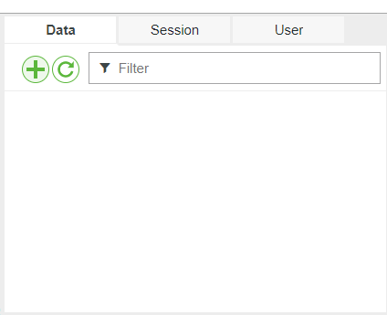

1. In the Add Data window select the Temperature_Sensor Thing
   1. Use the Entity filter to find the Thing

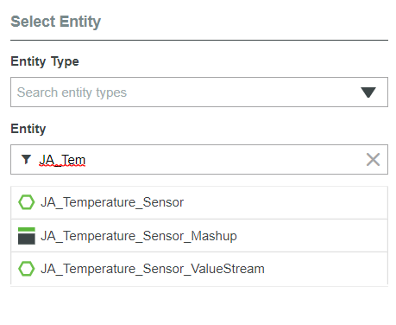

* 1. Use the Services Filter to find the QueryPropertyHistory Service and click on the arrow to select it

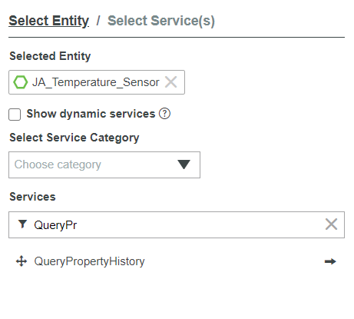

* 1. Check the Execute on Load checkbox

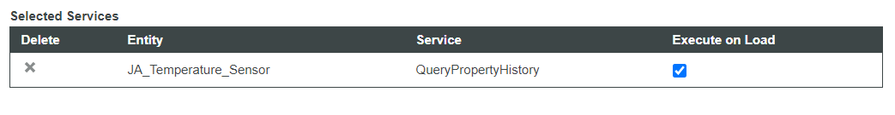

1. From the Data tab drag and drop All Data on the Time Series Chart

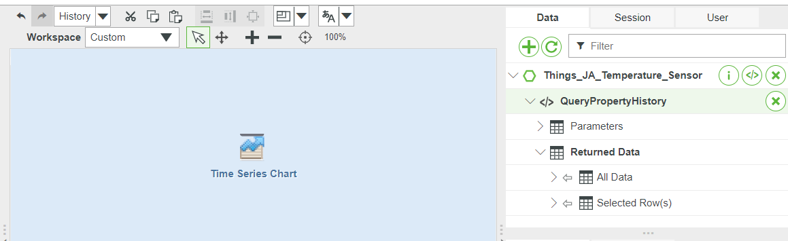

* 1. Select Data

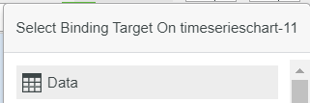

1. Your Bindings in the bottom should look like this

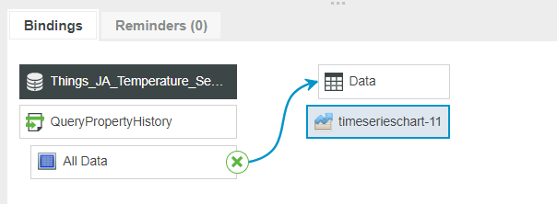

1. Click on the Time Series Chart
   1. On the left side you can see the Properties tab
   2. Select following values (use the Filter to find it quicker):

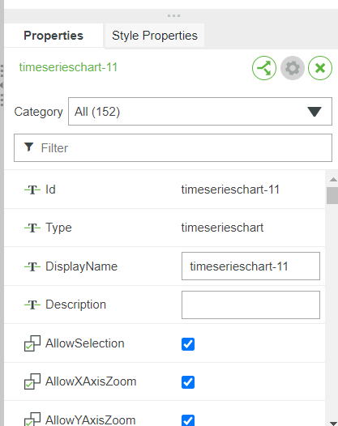



1. Now we need some data
   1. You can go to the Initials_Temperature_Sensor Thing and manually change the value of the Temperature property a few times
   2. Or you can use the provided python script that uses the Thingworx REST API to push property data
      1. Create New -> Application Key
      2. Name = Initials_Temperature_Sensor_Appkey
      3. Project = ESRAP_Meetings_Exercises
      4. User Name Reference = Select your own user (TWX will tell you that no admin user should be used)
      5. Save
      6. In the python script copy your generated Key ID and fill in your initials (example: '/Things/JA_Temperature_Sensor/Properties/*')



1. The script needs the “requests” package (pip install requests)
   1. Run the script from command line: python updateTwxProperties.py
   2. Tested with Python 3.7 and 3.9
2. In Thingworx Composer head back to your Mashup and click “View Mashup”, if you used the python script it will look like this:

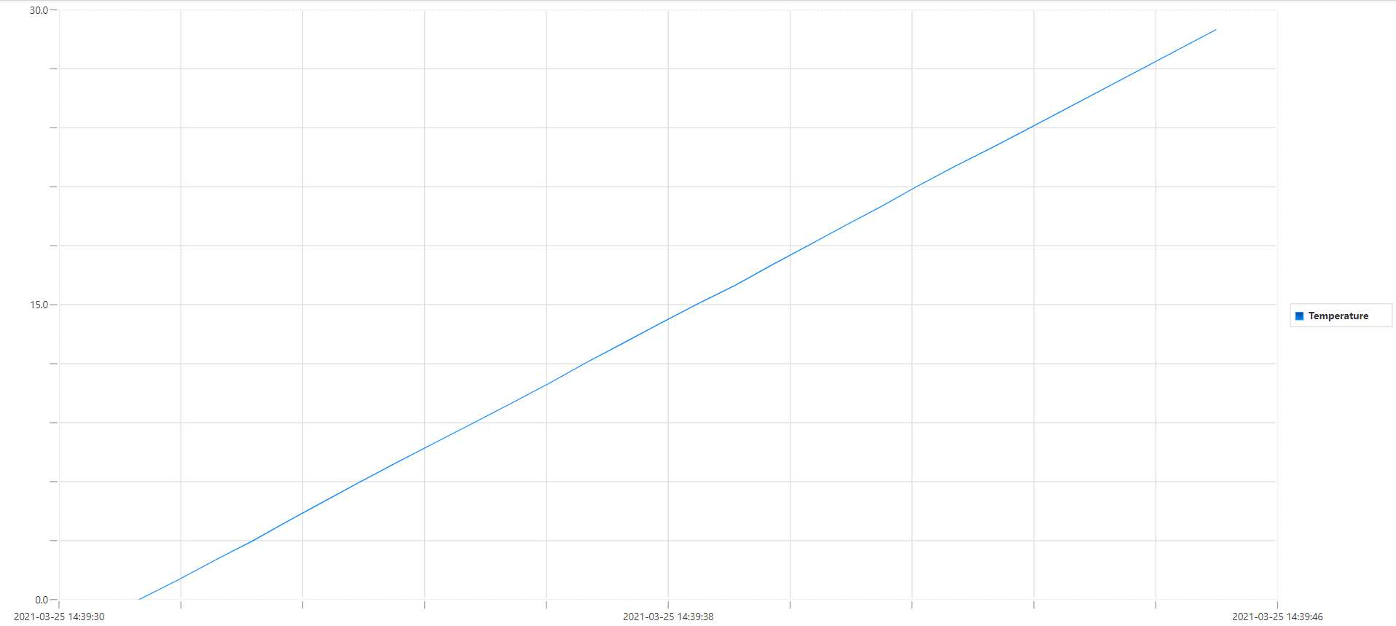

1. If you want to delete the stored data, use the PurgeAllPropertyHistory Service of the Temperature_Sensor Thing